1.
import java.util.*;
import java.io.*;
public class pgm {
public static void main(String[] args) {
Scanner sc=new Scanner(System.in);
float a=sc.nextFloat();
int b=sc.nextInt();
int c=sc.nextInt();
double regular_pay, overtime_payrate,overtime_pay, total_salary ,salary,penalty,result_salary;
regular_pay=40*a;
int overtime_hr=b-40;
if(b>40)
{
overtime_payrate = 1.5 * a;
overtime_pay=overtime_hr*overtime_payrate;
total_salary=regular_pay+overtime_pay;
result_salary=total_salary*c;
System.out.println(result_salary);
}
else if(b<20)
{
salary=b*c;
penalty=(salary*90)/100;
System.out.println(penalty);
}
else
{
System.out.println(b*c);
}
}
}
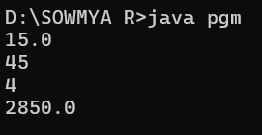
2.
import java.io.*;
import java.util.Scanner;
public class pgm {
public static void main(String[] args) {
Scanner scan = new Scanner(System.in);
String t = scan.nextLine();
int n = scan.nextInt();
double total = 0.0;
switch (t) {
case "Regular":
if (n > 10)
total = n * 50 * 0.90;
else
total = n * 50;
break;
case "VIP":
if (n > 5)
total = n * 100 * 0.85;
else
total = n * 100;
break;
case "Premium":
if (n > 3)
total = n * 150 * 0.80;
else
total = n * 150;
break;
default:
System.out.println("Invalid input");
return;
}
double ans = total;
if (total < 200)
ans = total +20;
System.out.println(ans);
}
}
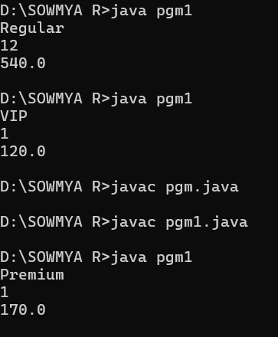
3.
import java.util.Scanner;
public class pgm1 {
public static void main(String[] args) {
Scanner scan = new Scanner(System.in);
int n = scan.nextInt();

int l = Integer.MIN_VALUE;
int s = Integer.MAX_VALUE;

while (n != 0) {
int digit = n % 10;
if (digit > l) {
l = digit;
}
if (digit < s) {
s = digit;
}
n /= 10;
}
System.out.println(s + " " + l);
}
}
